http://biogeonerd.blogspot.com/2013/03/brain-food-nutrition-for-learning-memory.html

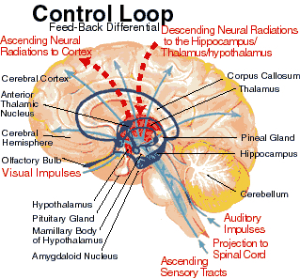

The reticular activating System is a net like group of cells that connect our brain stem, midbrain and cortex and is designed to filter out non-essential information base on what we focus on and by or beliefs about ourselves and life. The only thing that can get through is something that has pay value or something that is a threat.
As David Allen notes in “Getting Things Done”: referring to the Reticular Activating System.
“Just like a computer, your brain has a search function—but it’s even more phenomenal than a computer’s. It seems to be programmed by what we focus on and, more primarily what we identify with. It’s the seat of what many people have referred to as the paradigms we maintain”.
This aspect of our mind is subjective and believes what you tell it about yourself or what others have told you about you. It does not equivocate, it simply say’s ‘yes’ to whatever information it is/was given. As children we are ‘bland slates’ and do not have the emotional maturity to know any different than what we were told. In order to survive our families of origin we developed a survival skill set that I believe has created the behaviors that are outlined in the “Laundry List”.
If you were told anything other than; You are a magnificent, brilliant powerful being. You have been lied to. Our Reticular Activating System has mistaken this lie for your truth and is now in service to that lie!!!!

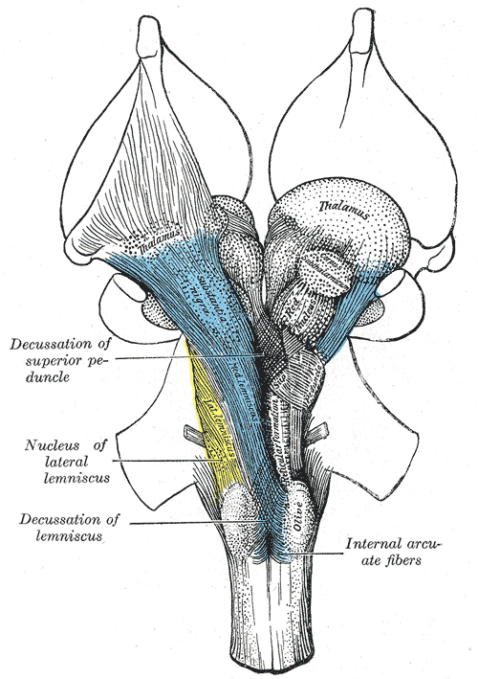
https://en.wikipedia.org/wiki/Reticular_activating_system

