4th Step Inventory With Your Other Hand

When feelings are experienced rather than denied, they lose their power!
Sitting with your feelings is an act of self -love.

What you need:

- Both Laundry Lists
- 12 Steps for Kids
- Promises
- Favorite Childhood Picture
(blow it up to 8×11)
- phone timer
- Paper and crayons
- Inner Family Blue Print

Thank your Critical Parent for all their help.
Ask them to step outside.

Cradle your child picture and gaze into your little one's eyes.

Say child's version of Steps1-3.
(We Can't He Can Let's Let Him)

Your love affair with your inner child has begun‍!

ASK: Pick a trait
Example: ILP (Inner Loving Parent) Read trait 5 (1st person) to inner child, repeating it slowly and allow the words to change as you read; like your singing them a song.
IC (Inner Child) you are breathing and listening to your ILP for 5 minutes.

ALLOW:
IC: Keep breathing and begin to write with your child’s hand (Non-Dominant Hand). You are safe... Let the words flow out of your pen...get ready to hear your child's voice (for 5 min).

LISTEN: Read what your child has written as you breathe and feel any feelings surfacing. Say the words on the blue print: calm, compassion, curiosity, competency.

WAIT: Make a promise from the promises list to your IC. Recite it lovingly,gently and with respect to your child. By making a promise you have made your child feel safe and reassured that they can trust you to be there for them as they continue their inventory.

Pick a flipside trait from laundry list and let your IC express. This will teach you to PRAISE your little one on a daily basis.
Repeat this process 10-14 days per trait.

Date and record on each letter from your child the trait and the promise you made them.

Once the space for an Inner Loving Parent opens, our inner child emerges and engages us in a loving, caring, discerning manner that often may surprise us.

Inner Family Blue Print
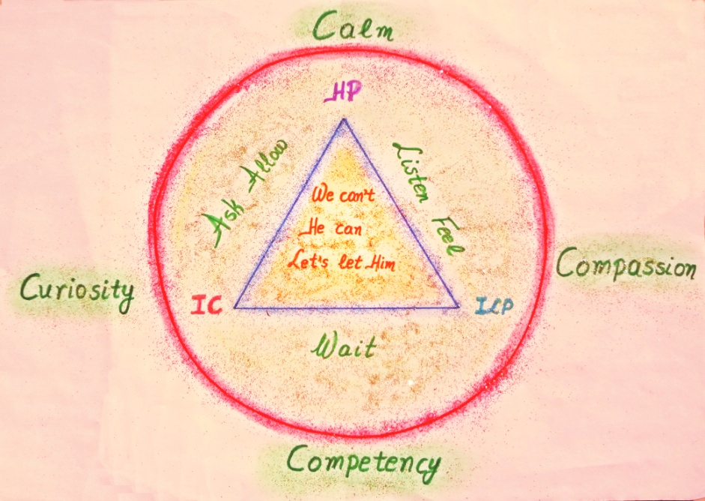
For more information and support using this tool contact:
Diana Blue-Sky

WhatsApp:
727-776-4968,
e-mail:
danceonfire10@gmail.com

